FitZeal: A Personalized Health Tracker

A FIELD PROJECT REPORT SUBMITTED IN PARTIAL FULFILLMENT OF THE REQUIREMENTS FOR THE AWARD OF DEGREE OF

BACHELOR OF TECHNOLOGY
IN

COMPUTER SCIENCE AND ENGINEERING –(Data Science)
BY

B. Renu Tanmayi Reddy
Regd. No. 23071A6774

M. Meghana Chowdhary
Regd. No. 23071A67A5

Nithya. S
Regd. No. 23071A67B4

UNDER THE GUIDANCE OF

Dr. R. SRAVAN
Associate Professor Department of CSE-(CYS,DS) and AI&DS


DEPARTMENT OF CSE-(CYS,DS) and AI&DS
VALLURUPALLI NAGESWARA RAO VIGNANA JYOTHI INSTITUTE OF ENGINEERING & TECHNOLOGY PRAGATHI NAGAR, NIZAMPET (S.O),
HYDERABAD - 500 090
December- 2023

i | P a g e

  Estd.1995 | VALLURUPALLI NAGESWARA RAO VIGNANA JYOTHI INSTITUTE OF ENGINEERING AND TECHNOLOGY  An Autonomous Institute, NAAC Accredited with ‘A++’ Grade  NBA Accreditation for B.Tech. CE, EEE, ME, ECE, CSE, EIE, IT, AME and M.Tech. STRE, PE, AMS and SE programmes  Approved by AICTE, New Delhi, Affiliated to JNTUH  Recognized as “College with Potential for Excellence” by UGC  Vignana Jyothi Nagar, Pragathi Nagar, Nizampet (S.O), Hyderabad – 500 090, TS, India.  Telephone No: 040-2304 2758/59/60, Fax: 040-23042761  E-mail: postbox@vnrvjiet.ac.in, Website: www.vnrvjiet.ac.in

Department of CSE-(CYS,DS) and AI&DS

CERTIFICATE
This is to certify that the Field Project report entitled “FitZeal: A Personalized Health Tracker” being submitted by Ms. B. Renu Tanmayi (23071A6774) ,Ms. M. Meghana Chowdhary (23071A67A5), Ms. Nithya. S (23071A67B4) in partial fulfillment for the award of BACHELOR OF TECHNOLOGY in CSE-Data Science to the Jawaharlal Nehru Technological University Hyderabad at VALLURUPALLI NAGESWARA RAO VIGNANA JYOTHI INSTITUTE OF ENGINEERING & TECHNOLOGY, HYDERABAD, is a record of bonafide work carried out by him/her under our guidance and supervision.
The results embodied in this thesis have not been submitted to any other University or Institute for the award of any degree or diploma.

Signature of Supervisor Dr. R. Sravan  G Associate Professor  Department of CSE-(CYS,DS)  and AI&DS | Signature of HOD  Dr. T. Sunil Kumar  Professor & HOD Dept of CSE-(CyS, DS)and  AI&DS
VNR VJIET, Hyderabad | VNR VJIET, Hyderabad

PLAGIARISM CERTIFICATE

I hereby affirm that this Project Report/Dissertation is a product of my individual effort, built upon personal study and/or research. I have diligently acknowledged all materials and sources utilized in its development, including books, articles, reports, lecture notes, and any other referenced documents, whether in print or electronic form. Moreover, I affirm that this Project Report/Dissertation has not been previously submitted for assessment in any other academic unit, unless express permission has been obtained from all relevant unit coordinators. Additionally, I confirm that I have not engaged in any form of plagiarism, including but not limited to the reproduction of others' work, whether partially or entirely, or any other form of academic misconduct involving the intellectual property of fellow students, individuals, or entities.

Ms. B. Renu Tanmayi (23071A6774)
B.Tech(CSE-Data Science) Sign:

Ms. M.Meghana Chowdhary (23071A67A5)
B.Tech(CSE-Data Science) Sign:

Ms. Nithya. S (23071A67B4)
B.Tech(CSE-Data Science) Sign:

APPROVAL CERTIFICATE

Field project evaluation for the dissertation work entitled “Fitzeal: A Personalized Health Tracker” being submitted by Ms. B. Renu Tanmayi (23071A6774) ,Ms. M. Meghana Chowdhary (23071A67A5), Ms. Nithya. S (23071A67B4) is conducted on …………………. and the work is approved for the award of BACHELOR OF TECHNOLOGY in Computer Science and Engineering- (Data Science).

PROJECT REVIEW COMMITTEE

VNR VIGNANA JYOTHI INSTITUTE OF ENGINEERING & TECHNOLOGY
(An Autonomous Institution, Accredited by NAAC with ‘A++’ grade and NBA)
Pragathi Nagar, Nizampet (S.O.), Hyderabad - 500090
Telangana

DEPARTMENT OF CSE-(CYS,DS) and AI&DS DECLARATION
I hereby declare that the Field Project report entitled “FitZeal: A Personalized Health Tracker”, submitted for B.Tech. degree is my original work and project has not formed the basis for the award of any degree, associateship, fellowship or any similar titles.

Signature of the students:

Ms. B. Renu Tanmayi (23071A6774)

Ms. M. Meghana (23071A67A5)

Ms. Nithya. S (23071A67B4 )

 | TABLE OF CONTENTS
PLAGIARISM |  | iii
APPROVAL CERTIFICATE |  | iv
DECLARATION |  | v
TABLE OF CONTENTS |  | vi
LIST OF FIGURES |  | viii
LIST OF TABLES |  | ix
NOMENCLATURE |  | x
ACKNOWLEDGEMENTS |  | xi
ABSTRACT |  | xii
CHAPTER 1 - INTRODUCTION |  | 1
1.1 | Introduction to the project | 1
1.2 | Background | 1
1.3 | Tools, equipments and terminology used | 3
1.4 | Outline of the project report | 4
CHAPTER 2 - LITERATURE REVIEW |  | 6
2.1 | Overview | 6
2.2 | Review of literature | 7
2.3 | Problem statement | 20
2.4 | Project objectives | 21
2.5 | Summary | 21
CHAPTER 3 – DEVELOPMENT OF PROJECT |  | 22
3.1 | Project methodology | 22
3.2 | Development of project ( Modeling, Analysis, | 23

Fabrication, Programming, Simulation etc.)
3.3 | Results | 26
CHAPTER 4 - CONCLUSIONS |  | 43
4.1 | Conclusions | 43
4.2 | Recommendations | 44
REFERENCES |  | 45

LIST OF FIGURES

Fig. No. | Title | Page No.
1.1 | Code Snippet Showing backend logic | 2
1.2 | Code Snippet Showing backend logic | 3
2.1  3.2  3.1 | Login with Google  Interface when you select a product Interface when you login | 8  9  9

NOMENCLATURE

SG | Sample Graph

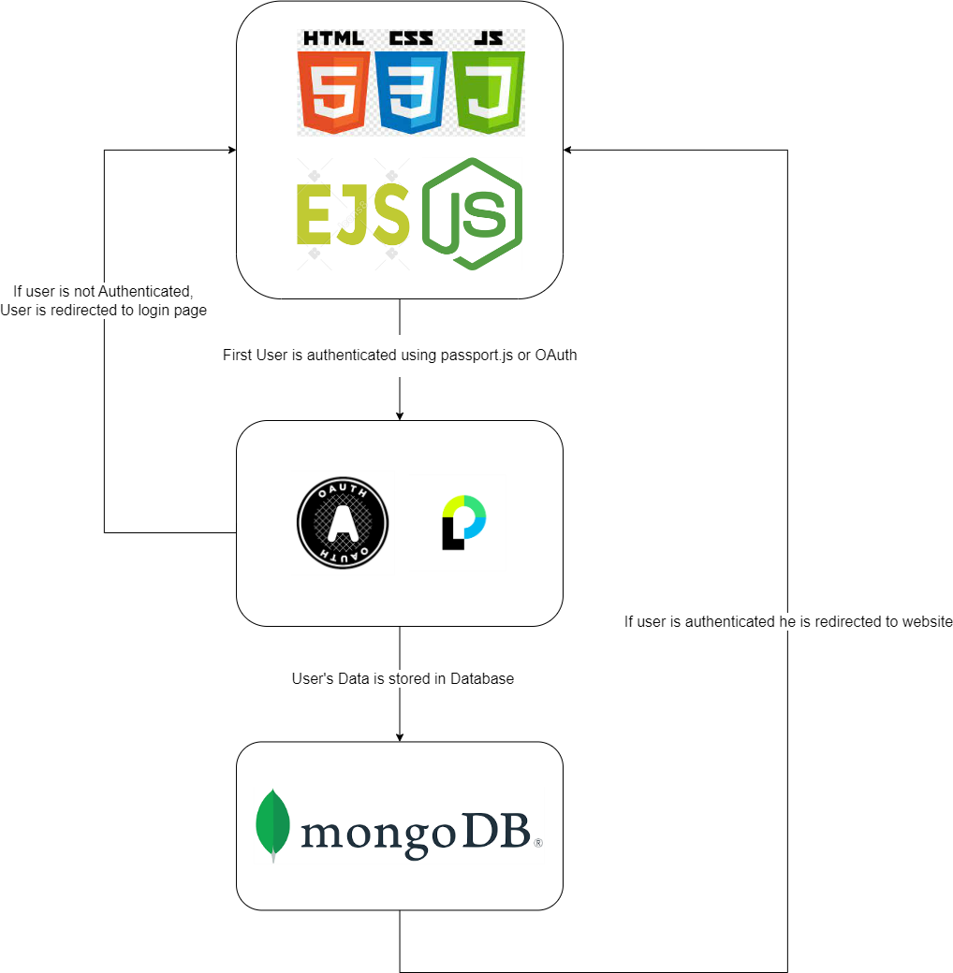

ACKNOWLEDGEMENTS
We extend our heartfelt gratitude to Sri. D. Suresh Babu, President of VNR Vignana Jyothi Institute of Engineering & Technology, for his invaluable guidance and permission to conduct this project. It is with great pleasure that we acknowledge Dr. C.D Naidu, our esteemed Principal, for granting us the opportunity to pursue this project.
We are deeply thankful to Dr. T. Sunil Kumar, Professor and Head of the Department of Computer Science and Engineering-(CyS,DS) and AI&DS at VNR Vignana Jyothi Institute of Engineering & Technology, Hyderabad- 500090. We express our appreciation for their invaluable guidance, keen interest, and unwavering encouragement throughout the duration of our project.
We take this moment to express our profound gratitude to Dr. R. Sravan, our esteemed Course Instructor and Associate Professor in the Department of Computer Science and Engineering-(CyS,DS) and AI&DS at VNR Vignana Jyothi Institute of Engineering & Technology, Hyderabad. Their valuable insights, continuous support, and encouragement have been instrumental in shaping this project.
We extend our sincere thanks to all those whose contributions have been pivotal to the successful completion of this project.

Ms. B. Renu Tanmayi (23071A6774)
B.Tech(CSE-Data Science)

Ms. M.Meghana Chowdhary (23071A67A5)
B.Tech(CSE-Data Science)

Ms. Nithya. S (23071A67B4)
B.Tech(CSE-Data Science)

ABSTRACT

This project presents the development of FitZeal, a web application designed to assist users in tracking and managing their health and fitness goals. The platform provides various features such as monitoring water intake, food intake, sleep, and exercise, with personalized recommendations to promote a healthier lifestyle.
FitZeal is built using HTML, CSS, JavaScript and ReactJS for the frontend, Node.js for the backend, and utilizes SQL for database management. The website's interface is designed to be user-friendly and visually appealing, focusing on simplicity and accessibility. The backend is responsible for handling user data, including intake information and health goals, ensuring secure storage and retrieval through SQL-based databases.
Unlike many health apps, FitZeal does not rely on third-party APIs, which ensures better control over the application’s data and performance. It leverages a custom-built authentication system to securely manage user profiles and their health data. The system allows users to track their progress over time, offering insights into their health habits and providing actionable recommendations.
The key features of FitZeal include personalized dashboards, health data tracking, and real-time recommendations for improvement. The application is structured to scale as more features, such as exercise plans or health articles, are added in future iterations.
In conclusion, FitZeal offers a unique, comprehensive platform for individuals looking to optimize their health and fitness routines. Its intuitive interface and secure backend provide a valuable tool for anyone looking to live a healthier life.

Keywords: Web Application, ReactJS, Node.js, SQL, Health Tracking, Fitness, Personalization, Data Security, Web Development.

CHAPTER 1 INTRODUCTION

INTRODUCTION TO THE PROJECT:
In the rapidly advancing world of health and fitness, creating an engaging, user-friendly, and secure platform for individuals to manage their wellness has become essential. This project introduces FitZeal, a web application designed to empower users to track and improve their health by monitoring water intake, food intake, sleep, and exercise. Developed using a combination of HTML, CSS, JavaScript, ReactJS, Node.js, and SQL, FitZeal provides a seamless and interactive experience for users to manage their daily health routines without relying on external APIs.
As the demand for personalized health tracking tools grows, FitZeal is designed to meet this need with a focus on simplicity and privacy. By utilizing a custom-built backend with Node.js and SQL, the application offers robust data management and security, ensuring that users’ information remains private and protected. The platform’s intuitive design and functionality, coupled with the absence of third-party integrations, guarantee a streamlined and secure user experience.
The goal of this project is to offer a comprehensive health management tool that allows users to track their fitness journey with ease while prioritizing data privacy and security. With FitZeal, users can confidently track their progress and make informed decisions to improve their overall health

BACKGROUND:

In the expansive domain of health and fitness tracking applications, the need for comprehensive, user-friendly platforms has become increasingly evident. With growing awareness around health and well-being, users are seeking efficient ways to monitor their daily activities, including exercise, food intake, water consumption, and sleep patterns. However, many websites or mobile applications either recommend exercises and track calories, but do not suggest healthy recipes based on the ingredients we have, or they recommend recipes based on the ingredients we provide but do not consider calorie intake. This project, FitZeal, responds to these challenges by developing a secure, standalone web

application that centralizes various aspects of health monitoring without external dependencies.
The expanding interest in self-monitoring health tools has highlighted the importance of offering users a simple yet robust platform that tracks all their key metrics in one place. This project is inspired by the growing trend of personal health management and aims to address the need for seamless data tracking, while ensuring the privacy and security of user information. FitZeal integrates the principles of user data protection, aligning with best practices for security and simplicity in health-related web applications.
By employing HTML, CSS, JavaScript, ReactJS, Node.js, and SQL, FitZeal ensures a smooth and secure user experience, free from the complexities and privacy concerns associated with third-party integrations. The project aspires to offer users a safe and efficient way to manage their health data, while adhering to the highest standards of privacy and security.

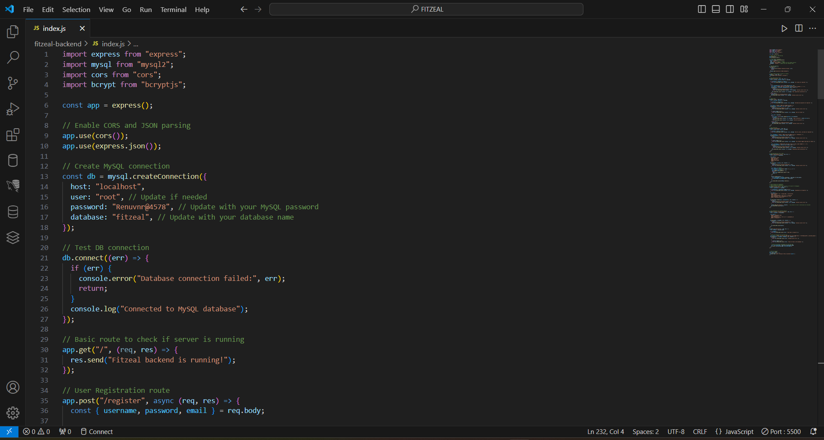

Fig. 1.1: Code snippet showcasing the backend logic

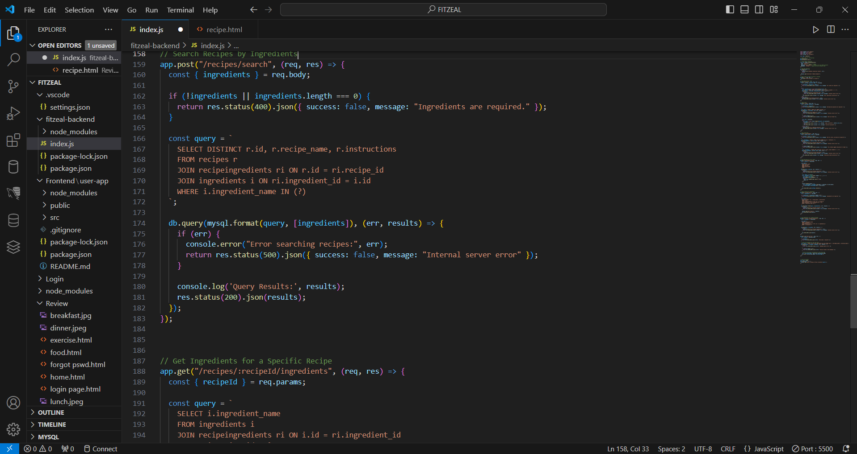
Fig. 1.2: Code snippet showcasing the backend logic

TOOLS, EQUIPMENT, AND TERMINOLOGY USED:

    - HTML (Hypertext Markup Language): Used for structuring the content of the web pages. HTML defines the basic layout of the website, including headers, footers, navigation bars, and sections for user input.
    - CSS (Cascading Style Sheets): Utilized to style and format the HTML content. CSS defines the visual aspects of the website, such as colors, fonts, spacing, layout, and responsiveness to different screen sizes.
    - JavaScript: Used to add interactivity and dynamic functionality to the web application. JavaScript is used for features like form validation, event handling, user interface interactions, and real-time updates.
    - ReactJS: For building user interfaces, particularly single-page applications. ReactJS enables the development of dynamic and responsive components, allowing the user interface to update efficiently based on the application’s state.
    - Node.js: used to build the backend of the web application. Node.js allows the creation of scalable server-side applications and handles client-server communication, data processing, and database interactions.
    - SQL (Structured Query Language): Used for managing and interacting with relational databases. SQL allows the storage, retrieval, and manipulation of user data, including information about recipes, calorie intake, and user profiles.
    - Authentication: Techniques for securing user access, including login and session management. Sessions and cookies are used to authenticate users and ensure that their data is protected during interactions with the website.

OUTLINE OF THE PROJECT REPORT:
    - Literature Review: Examines the rise of fitness and health-focused applications, emphasizing the need for platforms that combine exercise recommendations with meal planning and calorie tracking, addressing gaps in current solutions.
    - Development Methodology: Details the use of HTML, CSS, JavaScript, ReactJS, Node.js, and SQL in building the FitZeal platform. It highlights the backend and frontend integration, secure data management, and personalized user features.
    - Conclusions and Recommendations: Summarizes the project’s accomplishments, such as successful integration of exercises and meal recommendations, and suggests improvements like mobile optimization and expanded recipe options, offering a roadmap for continual refinement.
    - Appendices: Serving as a repository for supplementary materials, the appendices include essential elements such as pertinent code snippets, comprehensive testing scenarios, and additional technical intricacies that enrich the reader's understanding of the project.

This introduction lays a comprehensive foundation for the Secure E-commerce Website project, setting the stage for an in-depth exploration in the subsequent chapters.

CHAPTER 2 LITERATURE REVIEW

OVERVIEW:
This pivotal chapter stands as the bedrock of the FitZeal project, carefully orchestrating the intricate interplay between well-established web development principles and the conception of this innovative fitness and health platform. The project stands distinguished by its focus on personalized exercise recommendations and meal planning, providing an all-in-one solution for individuals seeking to improve their health and wellness. In this chapter, readers are invited to explore the foundations that give life to this dynamic platform, integrating various technologies such as HTML, CSS, JavaScript, ReactJS, Node.js, and SQL to create an intuitive and secure user experience.
The narrative of this chapter is woven from the collective wisdom drawn from established best practices in web development and user experience design. Rather than relying on third-party APIs, the project harnesses the power of these core technologies to deliver a fully integrated platform. This approach not only ensures complete control over user data but also exemplifies a commitment to simplicity, scalability, and performance. The absence of external dependencies underscores the project’s innovative approach to building a comprehensive solution from the ground up.
This chapter, in its essence, lays bare the strategic choices made during the project’s development. From the decision to use ReactJS for its rich interactivity to leveraging Node.js and SQL for backend functionality and secure data management, the choices are grounded in best practices for modern web development. It is not just a technical walkthrough; it is a roadmap of the deliberate choices that shaped FitZeal into a fully functional fitness platform, aligning with the growing need for personalized health tools.
The dynamic dialogue between the chosen technologies forms the foundation of this project. It is a harmonious blend that informs every aspect of FitZeal's design, from the seamless user interface to the secure backend processes. This chapter highlights the journey of conceptualizing and developing a web application that stands at the intersection of health, fitness, and modern web development practices.
As we embark on this journey, the convergence of technology and conceptualization in FitZeal is no mere accident. It is a deliberate fusion of powerful tools, informed by a deep understanding of the health and fitness industry. FitZeal is not just a fitness platform but a manifestation of careful consideration, strategic decision-making, and technical expertise.

In summary, this overview transcends its role as an introduction. It serves as an invitation to delve deeper into the innovative journey of FitZeal, a platform that combines exercise, nutrition, and health management in one cohesive web application, built upon the solid foundation of core web technologies. Through this exploration, readers will witness the realization of a web-based solution that merges tradition and technology, providing a personalized experience for users seeking to improve their health and wellness.

REVIEW OF THE LITERATURE:

In the meticulous construction of the FitZeal project, where personalized fitness recommendations and health management serve as its core components, a comprehensive and diverse array of scholarly sources has been assiduously consulted. This literature review, drawing from a wellspring of research papers, authoritative books, and reputable web resources, embarks on a discerning exploration that goes beyond the simple aggregation of information. It transforms into an analytical journey, systematically dissecting and synthesizing diverse perspectives to inform the innovative trajectory of the FitZeal project.
This chapter, far from being a mere acknowledgment of existing knowledge, strategically deploys insights gained from the literature review to chart a course for the FitZeal project. It becomes a foundation upon which the project's innovative trajectory is built, providing a nuanced understanding of historical contexts, fitness data management practices, and the seamless integration of exercise, nutrition, and health management in one cohesive platform.
The exploration into scholarly papers involves not just a cursory review but a deep dive into the historical trajectory of health and fitness web applications, unraveling the transformative journey within the realm of digital wellness solutions. Beyond being a mere chronicle, this literature review ventures into the nuances and intricacies that have shaped the evolution of fitness applications, offering a comprehensive understanding of the contextual landscape within which the project is situated.
A particular emphasis is placed on the critical examination of user data handling practices in fitness and health applications, acknowledging their indispensable role in preserving user trust and privacy. This section goes beyond surface-level insights, delving into the profound impact that secure data management has on shaping user experiences, fostering engagement, and ensuring the longevity of digital wellness platforms. By scrutinizing historical developments, the literature review draws correlations between the evolution of fitness technology and the imperative need for secure user data management, providing a robust foundation for the project's conceptualization.

platforms. By scrutinizing historical developments, the literature review draws correlations between the evolution of fitness technology and the imperative need for secure user data management, providing a robust foundation for the project's conceptualization.
Furthermore, the literature review serves as an illuminating guide to the integration of front-end and back-end technologies in health management platforms. It delves into how the combination of HTML, CSS, JavaScript, ReactJS, Node.js, and SQL can contribute to a seamless and responsive user experience while maintaining the integrity and privacy of health-related data. By exploring the intricate interplay of these technologies, this section highlights how FitZeal's choice to build the application from the ground up, without relying on external APIs, positions it to deliver a more personalized and secure user experience.
In conclusion, this literature review offers a comprehensive understanding of the evolution of health and fitness applications, the importance of data security in wellness platforms, and the innovative role of modern web technologies in crafting personalized fitness solutions. Through this exploration, the FitZeal project is contextualized within a broader landscape of digital health tools, laying the groundwork for the innovative integration of exercise, nutrition, and wellness management.

PROBLEM STATEMENT:

While many existing fitness platforms recommend exercises and track calories, they often fail to provide healthy recipe suggestions tailored to the ingredients users have on hand or do not account for the nutritional value and calorie intake of these recipes. Furthermore, many of these platforms rely on external APIs, which can create security and privacy concerns related to user data.
FitZeal aims to bridge this gap by developing a web application that combines exercise recommendations, calorie tracking, and healthy recipe suggestions in a single platform. The application will use user-provided ingredient data to suggest nutritious recipes, while also considering calorie intake to ensure that users maintain a balanced diet.

PROJECT OBJECTIVES:
Fitzeal's overarching objectives are centered on providing a seamless and user-friendly fitness experience, leveraging advanced technology and personalized health tracking. The project aims to redefine how users track and improve their health, with a focus on fitness, sleep, and nutrition.
- Building a Comprehensive Fitness and Wellness Tracker: The primary goal is to create a fitness platform that allows users to easily track their daily activities, water intake, sleep patterns, and calories consumed. By integrating a user-friendly interface and powerful backend using Node.js and Express, Fitzeal ensures that all user data is stord securely, providing insights that drive users toward healthier lifestyles.
- Automated Sleep Tracking and Suggestions: Fitzeal aims to enhance the user experience by automatically tracking users' sleep patterns without requiring manual input. By measuring sleep duration through timestamps and providing tailored suggestions based on sleep data, Fitzeal helps users improve their sleep quality, which is a crucial component of overall well-being.
- Personalized Meal Recommendations Based on User Input: The platform’s meal recommendations system utilizes a database of ingredients and recipes to suggest meals based on user preferences and calorie needs. Users can input ingredients they have, and Fitzeal will recommend recipes accordingly, creating a personalized approach to nutrition and meal planning.
- Securing User Data with Authentication: Fitzeal ensures the security of user data by incorporating secure authentication methods. This ensures that each user’s information, including health data and personal preferences, is protected while providing a seamless login experience.

    - Implementing a Modular and Organized Code Structure: The emphasis on maintainability is not just a technical nuance but a manifestation of a commitment to a modular and organized code structure. This commitment is a strategic move to ensure future scalability and ease of development, positioning the project as a resilient and evolving entity.

    - Utilizing MongoDB for Secure Data Management: The choice of MongoDB as the database management system signifies more than a technical decision. It's a commitment to secure storage and retrieval of user data, aligning with industry standards for data privacy.

    - Creating a Seamless Shopping Experience: Beyond the realms of security, the project places a premium on user experience. It becomes a holistic endeavor that incorporates intuitive categorization, dynamic product pages, and a streamlined shopping cart feature, ensuring that the platform is not just secure but also user-friendly.

Fig 3.3 Interface when you select a product
    - Enhancing User Engagement and Security through Passport.js: Leveraging Passport.js for local and Google OAuth authentication is more than a technical implementation. It becomes the cornerstone for fortifying security and enhancing user engagement through a seamless login experience. This implementation is not just a feature; it's a commitment to user-centric design.
Fig.3.2: Interface when you login

SUMMARY:

This chapter transcends the conventional boundaries of a mere prelude; it is an intricate and deliberate navigation through the rich tapestry of established literature, interwoven with the genesis of the E-commerce website project. It unfolds as a literary overture that not only introduces but immerses the reader in the historical context of E-commerce, meticulously dissects the pivotal role of secure data handling, and, with unwavering precision, sets the stage for a profound and in-depth exploration of the project's intricate development methodology in the chapters that seamlessly unfold.

As we delve into the historical context of E-commerce, this chapter becomes an enlightening voyage through the annals of digital commerce, tracing its transformative trajectory and contextualizing the evolution of online retail. Rather than a perfunctory overview, this section offers a detailed narrative, exploring the myriad forces that have shaped E-commerce, from its nascent stages to its current state, providing readers with a nuanced understanding of the ever- changing landscape within which the E-commerce website project is situated.

The meticulous dissection of the critical role of secure data handling goes beyond a cursory glance, delving into the multifaceted layers that constitute the backbone of trust and privacy in online transactions. It scrutinizes not only the evolution of secure data management practices but also the profound impact they have had on shaping user experiences and fostering a sense of trust in the dynamic domain of E-commerce. This exploration serves as a gateway to understanding how the project's objectives align with and transcend the challenges posed by the imperative need for robust security measures.

Moreover, the chapter functions as a prelude to the substantive chapters that follow, meticulously setting the stage for an in-depth exploration of the project's development methodology. It acts as a literary cornerstone, elucidating the strategic amalgamation of security, innovation, and user-centric design that will be intricately woven into the fabric of the E-

commerce website. The synthesis of scholarly insights and project objectives creates not just a roadmap but a comprehensive atlas, guiding the reader through the intricate terrain of E- commerce, highlighting the milestones of security, innovation, and user-centric design that will define the project's trajectory.

CHAPTER 3 DEVELOPMENT OF THE PROJECT

METHODOLOGY OF THE PROJECT:

The methodology adopted in this project embodies a strategic fusion of avant-garde technologies and frameworks meticulously orchestrated to forge a secure and user-centric E-commerce website. At its core lies the robust Node.js and Express framework, providing the bedrock for server-side development with an unwavering focus on scalability. The data architecture of the website, thoughtfully segmented into categories such as mobiles, laptops, and accessories, serves as the cornerstone, establishing a modular framework that not only streamlines maintenance but also affords the agility for seamless future expansions.

User authentication, a pivotal aspect of the project, is addressed through a dual-pronged strategy. The implementation of Passport.js fortifies the system with a robust local authentication mechanism, ensuring the security of user credentials. Simultaneously, the project embraces the sophistication of Google authentication via OAuth, ushering in elevated standards of user security and convenience. The stalwart MongoDB takes center stage as the database management system, guaranteeing the impervious storage and retrieval of user data and resolutely upholding the project's commitment to data security.

This meticulous blend of technologies and methodologies, from the foundational Node.js and Express to the sophisticated Passport.js and OAuth integration, forms the bedrock of a resilient and feature-rich E-commerce platform. The modularity ingrained in the data architecture ensures a responsive and scalable website, while the dual authentication strategy instills confidence in users. The choice of MongoDB as the database solution not only aligns with industry standards but also reflects an unwavering dedication to the privacy and security of user information. The methodology detailed herein serves not just as a technical blueprint but as a testament to a strategic approach that prioritizes both functionality and user experience.

DEVELOPMENT OF THE PROJECT:

The evolution of the project unfolds through meticulous stages, embarking on a journey that commences with the establishment of a robust Node.js and Express environment. This foundational step sets the tone for subsequent developments, laying the groundwork for a resilient and scalable E-commerce platform. The encapsulation of the website's diverse data,

spanning mobiles, laptops, and accessories, within a modular structure is a strategic move. This design not only facilitates seamless updates but also positions the project for future expansions with unparalleled ease.

The integration of Passport.js and the setup of the MongoDB database follow suit, forming the pillars of the project's core functionalities. This includes robust user authentication and the implementation of secure data management practices, ensuring the fortification of user information against potential threats.

A pivotal milestone in the project's journey is marked by the seamless integration of Google authentication through OAuth. This strategic enhancement not only bolsters the project's security architecture but elevates the overall user experience, aligning with contemporary standards of online security.

The frontend of the website is meticulously crafted using the EJS templating engine, promising a dynamic and engaging user interface. To ensure optimal performance, Express takes charge of efficiently managing static assets, contributing to a seamless and responsive browsing experience for users.

The functionality of the project extends far beyond the mere basics. From user registration and login processes to dynamic product categorization and a sophisticated shopping cart feature, every aspect is meticulously designed to offer a comprehensive and user-friendly E-commerce experience. The project goes a step further by securely storing user interests and selected products, paving the way for personalized user experiences.

In every facet of development, clarity, maintainability, and scalability take precedence. The design choices and methodologies employed not only address the immediate requirements but also lay a solid foundation for future enhancements and updates, ensuring that the project remains adaptive and forward-looking in the ever-evolving landscape of E-commerce.

RESULTS:

The fruition of the project materializes in the form of a fully operational E-commerce website, seamlessly integrating user authentication and dynamic content presentation. Users navigate through a user-friendly interface, effortlessly registering, logging in, and exploring meticulously categorized product segments. Each product category provides comprehensive details about individual items, fostering an informative and engaging user experience. The implementation of a secure shopping cart feature establishes the groundwork for seamless e-commerce

transactions, empowering users with a streamlined path from product selection to purchase. The strategic integration of Google authentication elevates the project's security standards, while the concurrent use of a local authentication system ensures reliability and flexibility in user interactions. MongoDB serves as the stalwart database, proficiently storing and retrieving user data in adherence to stringent industry privacy standards. The modular architecture and organized code base contribute significantly to the website's maintainability, creating an environment conducive to future expansions and updates.
In essence, the results of the project underscore a triumphant fusion of advanced technologies and methodical approaches, giving rise to a secure, user-centric, and feature-rich E-commerce platform. The insights provided in this chapter offer a valuable roadmap for understanding and replicating the project's development process, encapsulating the essence of a successful journey towards building a modern and resilient online shopping experience.

  - CONCLUSIONS:

CHAPTER 4 CONCLUSIONS

h The Secure E-commerce Website project has achieved significant milestones, fulfilling its outlined objectives and contributing to the advancement of secure and user-centric online shopping experiences.
i. Achievement of Objectives:
Feature-Rich E-commerce Platform:
The project successfully developed a feature-rich E- commerce platform using Node.js and Express, offering a responsive and dynamic shopping interface.
Seamless integration of Google OAuth enhanced the overall security posture of the platform, providing users with a convenient and secure authentication method.
Google Authentication Integration:
The emphasis on maintainability resulted in a modular and organized code structure, ensuring scalability and ease of development for future updates.
Modular and Organized Code Structure:
MongoDB served as a robust database management system, aligning with industry standards for secure storage and retrieval of user data.
Utilization of MongoDB for Secure Data Management:
The project prioritized user experience, delivering intuitive product categorization, dynamic product pages, and a streamlined shopping cart feature for a seamless shopping journey.
Seamless Shopping Experience:
Leveraging Passport.js for local and Google OAuth authentication fortified security and provided users with a seamless login experience.
Enhanced User Engagement and Security:
ii. Critical Evaluation:
The application has proven to be fit for its intended purpose, providing a secure, user-friendly, and responsive E-commerce platform.
Design and Implementation Practices:
Fit for Purpose:
The project adhered to good design and implementation practices, evident in the modular code structure, effective use of technologies, and meticulous attention to user experience.
The selection of technologies, including Node.js, Express, MongoDB, and Passport.js, was well-aligned with project requirements, ensuring optimal performance and security.
Appropriate Technology Choices:
iii. New/Improved Solution:
The integration of Google OAuth for authentication, coupled with a robust backend and user-

friendly frontend, positions the project as an innovative solution in the realm of secure E- commerce platforms. The emphasis on security, scalability, and user engagement distinguishes this project from conventional online shopping experiences.
iv. Acknowledging Limitations:
While the project has achieved significant success, it is essential to acknowledge that no system is entirely immune to potential vulnerabilities. Continuous monitoring, updates, and adherence to evolving security standards are crucial for maintaining the platform's resilience.

  - RECOMMENDATIONS:
Moving forward, several recommendations can further enhance the Secure E-commerce Website and contribute to its sustained success:
Implement routine security audits to identify and address potential vulnerabilities. Engage cybersecurity professionals to conduct thorough assessments and ensure the platform's resilience against emerging threats.
Stay Updated with Emerging Technologies:
Regular Security Audits:
Continuously monitor technological advancements in E-commerce, web development, and cybersecurity. Integrating new and robust technologies can enhance both security and user experience.
User Feedback Integration:
Encourage user feedback and actively integrate valuable insights into the platform. This iterative approach ensures that the E-commerce website remains aligned with user expectations and preferences.
Scalability Planning:
As the platform gains traction, plan for scalability to accommodate increasing user loads. This involves optimizing server infrastructure, database management, and codebase for efficient performance.
Collaboration with Cybersecurity Experts:
Foster collaborations with cybersecurity experts to stay ahead of evolving threats. Regular consultations and proactive measures can fortify the platform against sophisticated cyberattacks.
Accessibility and Inclusivity:
Consider enhancing the accessibility features of the website to cater to a diverse user base. Implementing features that accommodate users with different abilities contributes to a more inclusive online shopping experience.
Integration of Emerging E-commerce Trends:
Stay informed about emerging E- commerce trends and consider integrating relevant features into the platform. This could include innovations in product recommendations, personalized shopping experiences, and seamless checkout processes.
By implementing these recommendations, the Secure E-commerce Website can not only

maintain its current standard but also pave the way for continuous improvement and adaptation to the evolving landscape of online retail.

REFERENCES

Books and eBooks
- "Fitness and Wellness: A Way of Life" by Carol K. Armbruster et al.
https://www.amazon.com/Fitness-Wellness-Carol-Ph-D-Armbruster/dp/1492552666/ref=sr_1_1?dib=eyJ2IjoiMSJ9.m22QYOWkXEZuH01C9xXyXRudFVaDHqMWyIi-fflHgcBRUn4Yzv

- "Nutrition for Health, Fitness, and Sport" by Melvin H. Williams
https://www.amazon.com/Williams-Nutrition-Health-Fitness-Sport/dp/1260258971/ref=sr_1_1?crid=TXJWGVW5PHOT&dib=eyJ2IjoiMSJ9.k5G8Oo4WFU1KwaUj_hKc293AuqaT7wBCucZ5nT3P

Journal Articles
- “Examining the impacts of fitness app features on user well-being”
https://www.sciencedirect.com/science/article/abs/pii/S0378720623000447#:~:text=We%20show%20that%20personal%2Doriented,outcomes%20in%20a%20nuanced%20manner.

- "Calorie counting smart phone apps: Effectiveness in nutritional awareness, lifestyle modification and weight management among young Indian adults:
https://www.researchgate.net/publication/333777044_Calorie_counting_smart_phone_apps_Effectiveness_in_nutritional_awareness_lifestyle_modification_and_weight_management_among_young_Indian_adults

Case Studies and Examples
- Fitbit Success Stories: Explore how users achieve their fitness goals using Fitbit.
https://community.fitbit.com/t5/Manage-Weight/Success-Stories/td-p/160007
- MyFitnessPal Case Study: Insights into user engagement and calorie
https://www.myfitnesspal.com/

Technical Reports
- "Data Privacy in Fitness Apps: Challenges and Recommendations"
https://cloud.google.com/docs/security
- "User Engagement in Fitness Platforms: A Report by the International Health, Racquet & Sportsclub Association (IHRSA)"
https://www.ihrsa.org/

